**Team Mayhem**

# **Hypothesis:** U.S. automobile accidents have increased significantly with the introduction of smartphones.

Adoption of the smartphone in the US really began to take off with the introduction of the iPhone in June 2007. The chart below shows the number of smartphone users in the US from 2010, when less than 20% of the US population owned a smartphone, to 2018, when over 80% own one.

We used this data from Statista (<https://www.statista.com/>) to evaluate relationships between total accidents and fatalities from car accidents and the adoption of smartphones by all users We also then subdivided drivers into age categories (15 -21, 21 – 64 and 65+).

# Question 1: Did the total number of automobile accidents and fatalities from accidents in the US change as a result of the introduction of the smartphone?

The National Highway Traffic Safety Administration (<https://www.nhtsa.gov/>) provides a query application on its website for accessing total accident data. This data was used to run a regression against the number of smartphone users per year. The chart below shows the results form this regression. The R-squared value for this regressions is 0.862 which suggests there is somewhat of a correlation between the adoption of smartphones and total automobile accidents from 2010 – 2018.

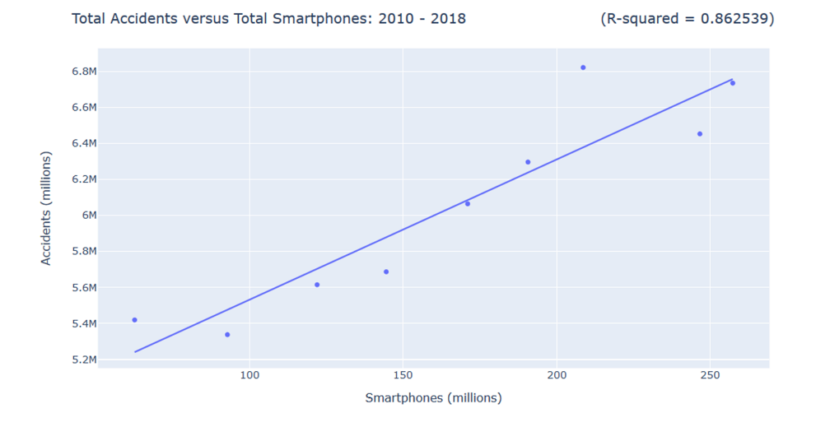

Data for automobile fatalities proved to be more difficult to obtain. NHTSA provides access to automobile accident fatalities data (<https://crashviewer.nhtsa.dot.gov/CrashAPI>), however it limits API requests to 5000 data points per request. We selected the top most populated states (CA, FL, IL, NY, OH, PA, TX and CO) as a sample in an effort to include a maximum number of data points (we had observed that states with lower populations had fewer accidents). We included Colorado because we live here. The chart below shows the annual fatalities from car crashes for these states from 2010 – 2018.

To determine whether the number of fatalities from automobile accidents and the adoption of smartphones in the US are related we ran a regression. The chart below shows the result of this regression. The R-squared and p-values are .929 and .0003, respectively. These values would suggest that the number of fatalities from car accidents and the number people owning smartphones ARE correlated.

# Question 2: Did the rate of automobile fatalities change as mobile apps become more prevalent?

As the smartphone evolved so did the things a user could do with it. More and more applications were developed for smartphones which increased user engagement. The chart below shows the monthly active users (“MAUs”) for the top 20 mobile apps from 2002 to 2018. Not only does this data echo the increasing adoption of the smartphone but also it demonstrates the increased engagement of each user.

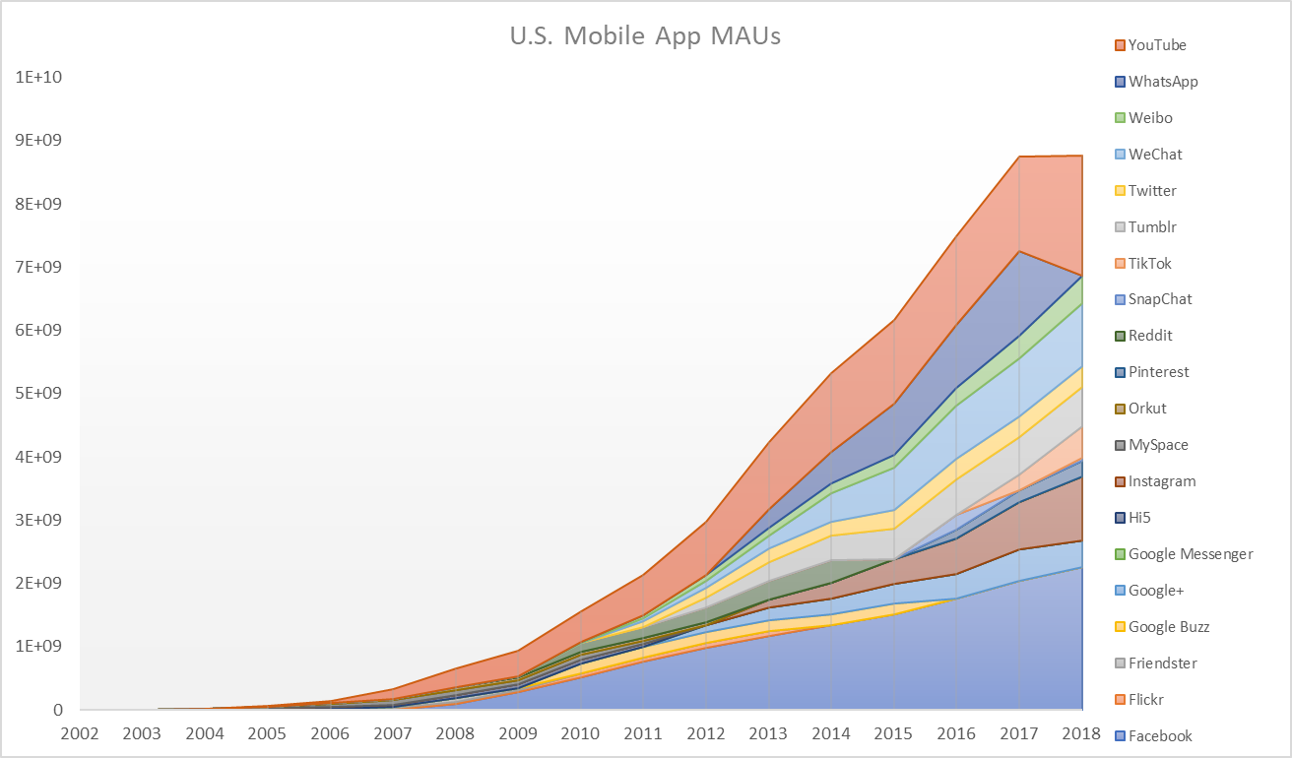

A regression comparing automobile the total accident fatalities in the states listed above from 2010 - 2018 versus the total number of MAUs for the top 20 mobile apps is shown below.

The R-squared and p-values for this regression are .900 and .0009, respectively. These values both suggest that the relationship between these variables is significant, that the number of fatalities from car accidents is correlated to the MAUs of mobile apps.

# Question 3: Does age impact the rate of fatalities from automobile accidents?

To examine whether age might influence total automobile accidents we broke drivers into three age categories, 15 – 21, 21 – 64 and 65+, and performed regressions comparing each category to the total number of accidents. The resulting charts are below including the R-squared value for each.

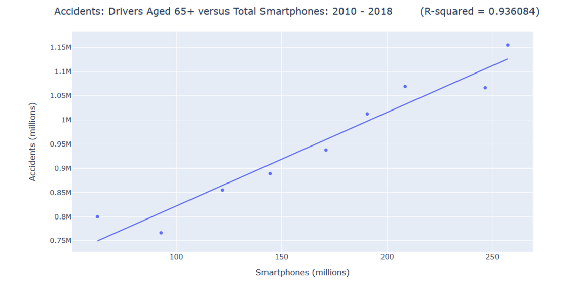

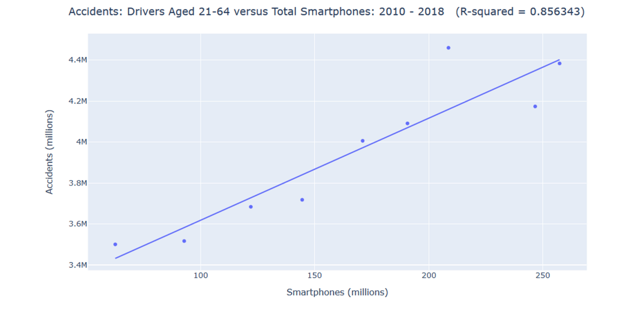

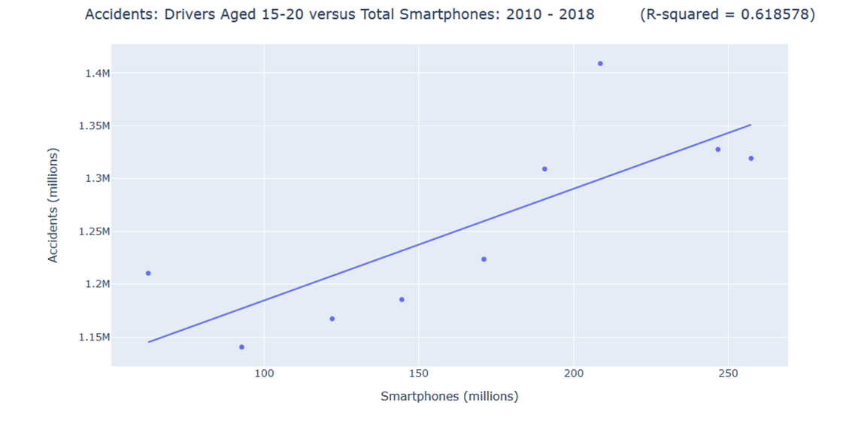

Drivers 65+ have the highest R-squared value suggesting of the three age categories this age group is most highly correlated to the total number of automobile accidents.

Limitations:

Accessing data from the FARS site was limited to 5,000 requests at a time. This made calling all accidents difficult and very time consuming. This contributed to why we focused on total fatalities per state versus all accidents. We made the assumption that the percent of accidents that are fatalities translates across states (though population density may impact this). Also impacted the number of states’ data we pulled

Other things could influence each of the variable: population growth affects both, limited number of data points as data is aggregate data.

Follow-on questions:

Find mobile app MAUs and smartphone users by age and run regressions comparing age groups and whether they are more / less affected by smartphone use.